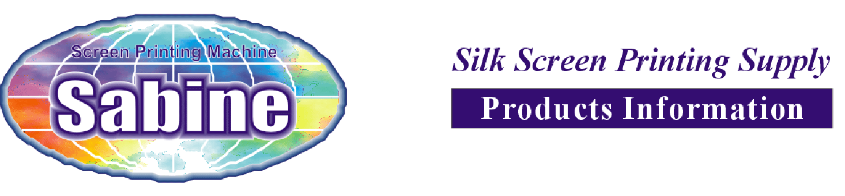

Laser Cutting and Engraving Machine
LCE1259

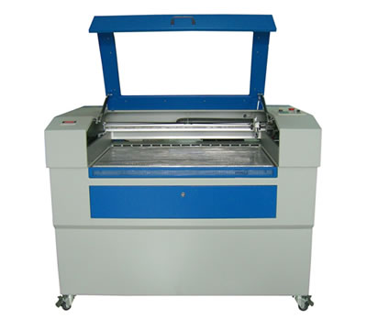

Equipment performance
The double guide rail, step drive, belt transmission, tube feeding, up & down worktable, the honey-comb striation, the circulation of water cooling, the hydraulic protection, exclusion of dust and smoke, the huff protection, the proprietary software which supports the output of various files format: PLT, BMP, DXF, DST, T100, etc.

Laser power | 60W - 80W – 100W
Worktable size | 1250X900mm
Cutting speed | ≤500mm/s
Engraving speed | ≤1000mm/s
Repetition precision | ≤±0.025mm
Cooling ways | Circulation water cooling
Connecting ways | PCI CARD/ ONLINE
Working power | 220V / 50Hz / 1kVA
Net weight | 380KG
Cubage | 3.35M3

Bourj Hammoud Dora Highway facing Arab Bank, Jirair Kaprielian Bld. 1st Tel. +961-1-259215 Mobile +961-3-388326
Beirut - Lebanon
www.sabinecolors.com e-mail: sabinecolor@yahoo.com
LCE1259 Laser Cutting and Engraving Machine Information

Application
Advertising industry, decoration, furniture, model manufacturing, and handicraft industry. The machine is widely applied in the fine engraving, cutting and hollowing out on non metallic materials like acrylic, organic board, double color plate, plank, bamboo product, paper, glass, etc. With all kinds of characters, graphs, images, trademarks and so on.

Optional configuration
Red-light locating system; Rotary device. The machine will fix red-light position system, up & down worktable, safe switch, huff-protection system.

The tube is CO2 sealed laser tube. life time: 1200hrs / 3 month

Memo
Strictly produced with CE standard. Imported Guide Rail and Focus Mirror

Note: As for Co2 laser tube life time, i am sure at least you can use 1200 hours, you are right, if you use the machne 10 hours/month, that means you can use the tube 1 year at least. Moreover, if you customer is a strong purchasing power and he doesn't like change tube several monthes again and again, we also can fix imported RF tube(Radio Frequency Metal Tube) for him, just more expensive, 30W,50W,70W,100W can be supplied, it has more higher precise and life time and stability of laser beam.

I think what you customer should pay attention is:1, our products have past CE standard, 2,Focus mirror and Guide rail is imported from USA and Korea, 3,we can supply whole after service, we have very strong technical team, it is our core which help our company continues fast development in nearly 13 years.

Bourj Hammoud Dora Highway facing Arab Bank, Jirair Kaprielian Bld. 1st Tel. +961-1-259215 Mobile +961-3-388326
Beirut - Lebanon
www.sabinecolors.com e-mail: sabinecolor@yahoo.com

