

TRL80LJ Inkjet Light Transfer Paper
1/3

Product: Light inkjet Transfer Paper (hot peel)
Description: with inkjet, a single step to make transfer for light colored fabrics Ink Compatibility: water based Dye & pigment ink.
1.Application
This product is recommended with wax crayons, Oil pastels, fluorescent markers, color pencil, Mild solvent ink, Eco-solvent ink, Water based pigment or Dye inkjet ink (NOT recommend to use sublimation ink) for white or Light-colored T-shirts, aprons, gift bags, mouse pads, photographs on quilts etc. The transfer peels off with hot and can be applied with a regular household iron or professional heat press machine.
2. Advantage
◆ Customize Fabric with favorite photos and color graphics
◆Designed for vivid results on white or light-colored cotton or cotton/polyester blend fabrics
◆Ideal for personalizing T-shirts, canvas bags, wool garment, aprons, gift bags, mouse pads, photographs on quilts etc.
◆Transfer peels off easily with hot.
◆Iron on with a regular household iron & Heat Transfer Press machines
3. Compatibility for Light inkjet Transfers
It can be printed with water inks in most printers such as: Epson Stylus Photo 1390, R270, R230, PRO 4400, Canon PIXMA ip4300, 5300, 4200, i9950, ix5000, Pro9500, HP Deskjet 1280, HP Photosmart D7168 , HP Officejet Pro K550 etc. Color laser printers: Epson AcuLaser CX11N, C7000, C8600, Fuji Xerox DocuPrint C525 A, C3210DX, Canon laser shot LBP5600・LBP5900・LBP5500・LBP5800, Canon CLC1100・CLC1130・CLC1160・CLC5000, CanoniRC2620・3100・3200.

Dora Highway facing Arab Bank, Jirair Kaprielian Bld. 1st Tel. +961-1-259215 Mobile +961-3-388326
Beirut - Lebanon
www.sabinecolors.com e-mail: sabinecolor@yahoo.com

TRL80LJ Inkjet Transfer Paper Product Information

2/3

4. Printer Recommendations
1) Store TRL80LJ in its original packaging in a cool, dry place.
2) Only print onto the unprinted, coated side of transfer paper, select normal mode and mirror mode on your printer.
3) Printer settings: normal paper mode using photo quality print quality
4) Before transferring, leave the printed image to dry for approx. 5 minutes, cut out the motif without leaving a margin around the edges. Straight after peel off the transfer film from the paper back.
5) First print the desired motif onto standard paper to check that the color and size are correct..
6) Compatibility: It is designed to work with water based Dye & pigment ink.

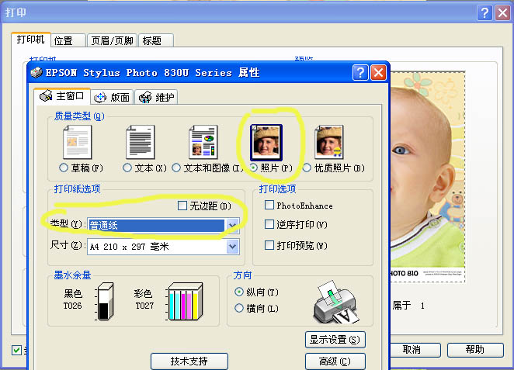

5. Iron-on Transfer Processing

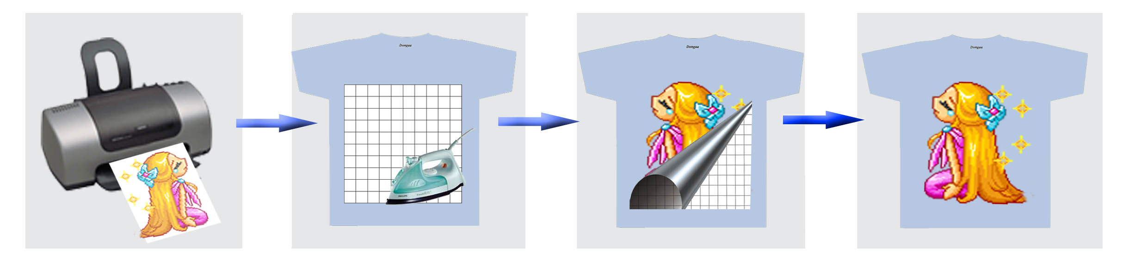

Dora Highway facing Arab Bank, Jirair Kaprielian Bld. 1st Tel. +961-1-259215 Mobile +961-3-388326
Beirut - Lebanon
www.sabinecolors.com e-mail: sabinecolor@yahoo.com
TRL80LJ Inkjet Transfer Paper Product Information

3/3

A. Prepare a stable, heat-resistant surface suitable for ironing on.
B. Preheat the iron to the highest setting, recommended ironing temperature 200°C.
C. Before transferring, leave the printed image to dry for approx. 5 minutes, cut out the motif without leaving a margin around the edges.
D. Briefly iron the fabric to ensure that it is completely smooth, then place the transfer paper onto it with the printed image facing downwards.
E. Do not use the steam function. Make sure that the heat is evenly transferred over the entire area. Iron the transfer paper, applying as much pressure as possible. When moving the iron, less pressure should be given. Don't forget the corners and edges.
F. Continue ironing until you have completely traced the sides of the image. This entire process should take about 60-70 seconds for an 8"x 10" image surface. Follow-up by ironing the whole image quickly, heating all of the transfer paper again for approximately 10-13 seconds.
G. Peel the transfer starting at the corner with hot.

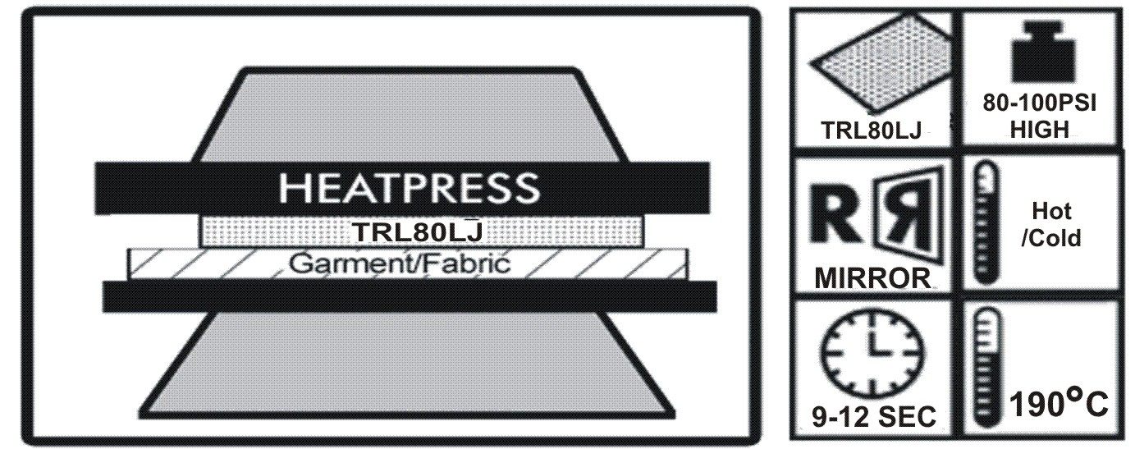

6. Heat press machine Transfer processing.
A. Set heat press machine at 190°C, for 10 second using high pressure.
B. Briefly heat the fabric for 5 second to ensure that it is completely smooth.
C. Before transferring, leave the printed image to dry for approx.5 minutes, cut out the motif without leaving a margin around the edges.
D. Place transfer paper onto fabric with the printed image facing downwards.
E. heat press machine at 190°C, for 10 second.
F. Peel off the back paper starting at the corner with hot.

7. Washing Instructions
1) waiting 24 hours before washing for the first time (drying time)
2) Fabrics bearing our transfers are machine-washable up to 30°C, always wash garments inside out.
3) Do not use aggressive washing detergents or bleach of any kind
4) Do not tumble-dry
5) Iron only on the reverse side. .
8. Material Storage
conditions of 35-65% Relative Humidity and at a temperature of 10-30°C.

Dora Highway facing Arab Bank, Jirair Kaprielian Bld. 1st Tel. +961-1-259215 Mobile +961-3-388326
Beirut - Lebanon
www.sabinecolors.com e-mail: sabinecolor@yahoo.com

